Lesson 23: Mini Weather Station

1.DHT11 Temperature & Humidity Sensor:
DHT11 Temperature & Humidity sensor is a temperature and humidity composite sensor with calibrated digital signal output, it includes a resistive humidity sensing element and an NTC temperature measuring element, and is connected with a high-performance 8-bit microcontroller.
Its application-specific digital module acquisition technology and temperature and humidity sensing technology ensure that the product has extremely high reliability and excellent long-term stability.
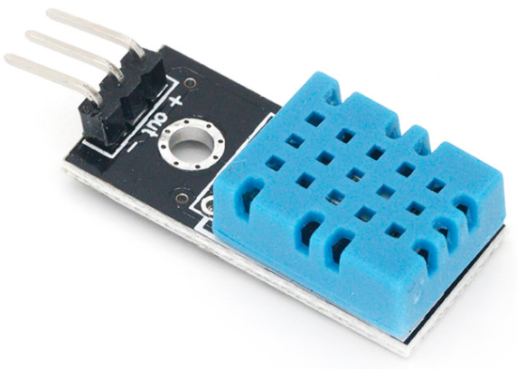

2.Project Introduction:
The ambient temperature value and humidity value are monitored in real time through the DHT11 Temperature & Humidity sensor, and displayed on the LCD1602 module synchronously. When the temperature is too high or the humidity is too low, it will trigger the LED light to turn on and off to remind.
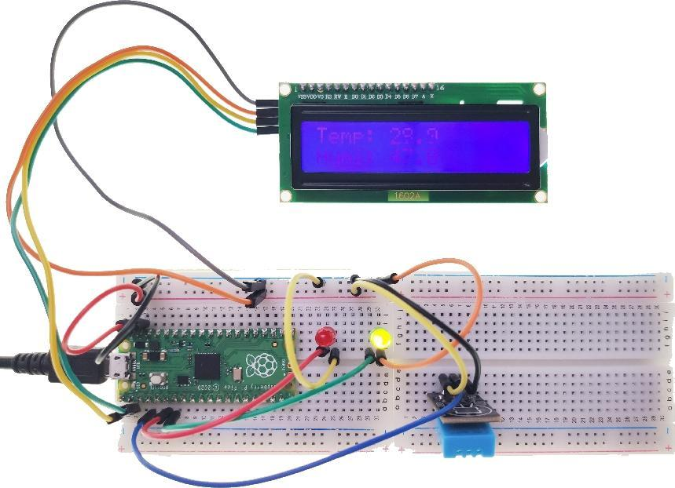

3.Circuit connection:
3.1 Material preparation: Raspberry Pi Pico*1, USB cable*1, Breadboard*1, DHT11 Temperature & Humidity sensor*1, LCD1602*1, LED(R)*1, LED(G)*1, Dupont line;
3.2 Port connection:
Raspberry Pi Pico | DHT11 Temperature & Humidity sensor
VSYS | +
GND | -
GP2 | out

Raspberry Pi Pico | LCD1602
GP0 | SDA
GP1 | SCL
VSYS | VCC ( + )
GND | GND ( - )

Raspberry Pi Pico | LED(R)
GND | - (short)
GP4 | + (long)

Raspberry Pi Pico | LED(G)
GND | - (short)
GP5 | + (long)

4.Library file installation:
Upload the “lcd_api.py”, “i2c_lcd.py” and “dht.py” library file to the Raspberry Pi Pico. For the specific operation steps, please refer to Lesson 16.

5.Program analysis: Mini Weather Station
from machine import I2C, Pin
from i2c_lcd import I2cLcd
from utime import sleep
from dht import DHT11, InvalidChecksum

DEFAULT_I2C_ADDR = 0x27 # LCD 1602 I2C address
# If 0x27 doesn't respond then 0x3f is used
led_red = Pin(4,Pin.OUT)
led_green = Pin(5,Pin.OUT)
pin = Pin(2, Pin.OUT, Pin.PULL_DOWN)
dht11 = DHT11(pin)

def setup():
global lcd
i2c = I2C(0,sda=Pin(0),scl=Pin(1),freq=400000)
lcd = I2cLcd(i2c, DEFAULT_I2C_ADDR, 2, 16) # Initialize(device address, cursor settings)

def loop():
try:
while True:
lcd.move_to(0,0)
lcd.putstr("Temp: {}".format(dht11.temperature))
lcd.move_to(0,1)
lcd.putstr("Humi: {}".format(dht11.humidity))
if dht11.temperature > 35 or dht11.humidity < 10:
led_red.value(1)
led_green.value(0)
sleep(0.5)
led_red.value(0)
sleep(0.5)
else:
led_red.value(0)
led_green.value(1)
sleep(1)
lcd.clear()
except InvalidChecksum:
print("Checksum from the sensor was invalid")
if __name__ == '__main__':
setup()
loop()

